Lab 3
Mount
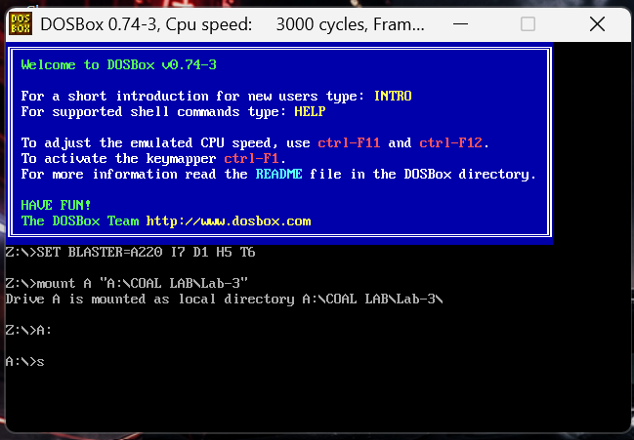

Task 1
- Part A
Physical Address = (Segment × 10h) + Offset
Physical Address =(1000h x 10h) + 0050h
Physical Address =10000h+0050h
Physical Address =10050h

- Part B
Physical Address =(19F5h x 10h) + 0FFFEh
Physical Address =19F50h + 0FFFEh
Physical Address = 29F4Eh

- Part C
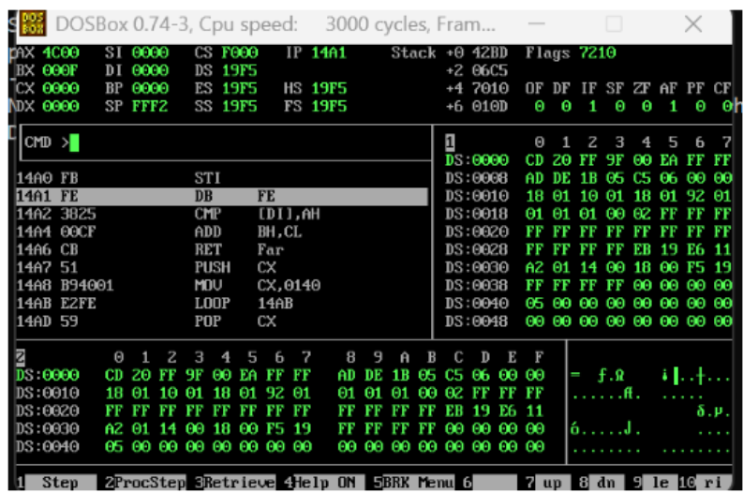
CS = F000
IP = 14A1
DS = 19F5
Physical Address = (CS × 10h) + IP
Physical Address = (F000 × 10h) + 14A1
Physical Address = F0000h + 14A1h
Physical Address = F14A1h

Task 2
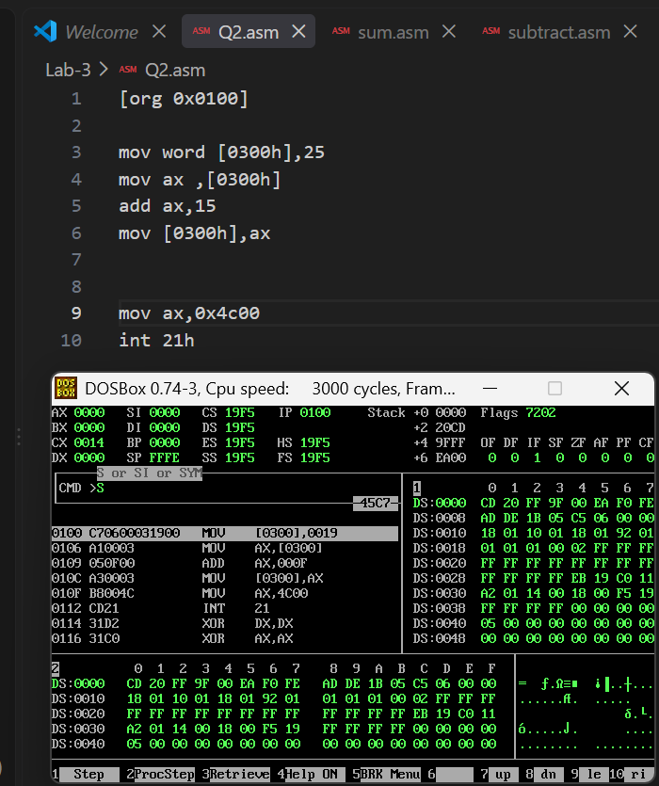
Execution
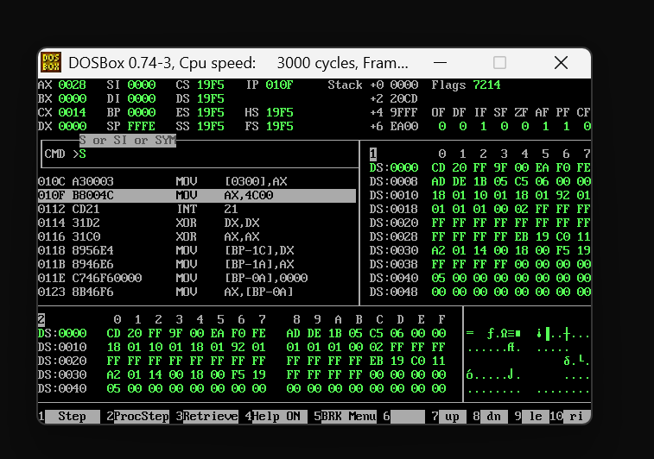
Terminate
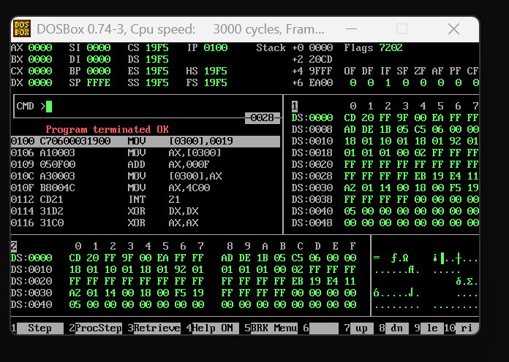

Task 3
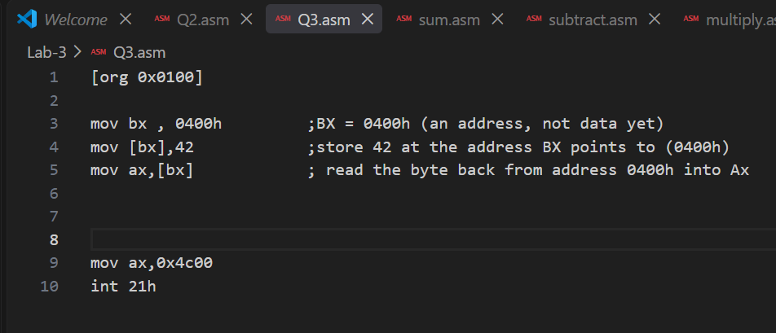

Task 4
Direct addressing
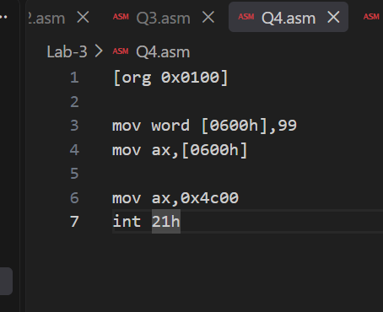
Indirect addressing
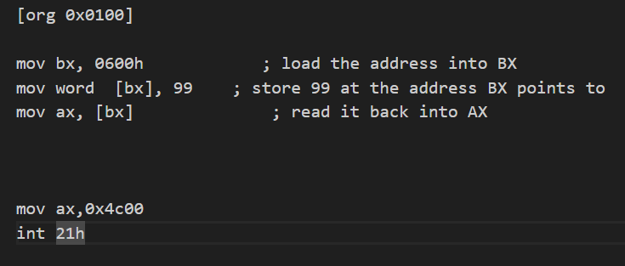

Direct addressing: fewer instructions, but the address is fixed and can't change.
Indirect addressing: one extra instruction, but the address is stored in a register and can change
++++++++++++++++++++++++++++++++++++++++++++++++++++++++++++++++++++

